High Voltage Battery Gauge (SoC) – PHEV/HEV

Functional Description

The purpose of the High Voltage Battery Gauge feature is to inform the driver of the vehicle’s State-of-Charge for the Battery.

The Battery Gauge correlates the BattTracSoc_Pc_Dsply,RgenActv_B_Dsply and the Operational Mode to generate gauge level displaying the vehicle’s current State-of-Charge for the battery and the corresponding graphic to be displayed.

The Battery Gauge shall be capable of indicating the maximum State-of-Charge. The raw input is filtered by the cluster for smooth and continuous level indicator movement (this is a slow moving signal, so minimal filtering from the cluster is required).

For the state of Charge (SoC), the Battery shall provide a vertical gauge with a blue variable fill pointer on a LCD. The Battery Gauge pointer shall rise from a rest position to indicate increasing state of charge, and fall to indicate decreasing state of charge. The SoC could be enabled/disabled based on [y]_Battery_Charge_Level_MC [x] flag.

This change in China Market is required to meet the GBT4094.2 Regulation in China for any vehicle sold after July 2019 Date. Changes affect the HV Battery SOC display. GBT4094.2 2017 China Regulation supersedes GBT4094 2005 China Regulation and due to this regulation Battery Gauge SOC Display will be Changed with battery symbol and SOC%.

Also “Battery Display” Menu is no longer applicable.This is a global implementation and not specific to China.

Interfaces

Interface Context Diagram (I/O Block Diagram)
Figure 1 High Voltage Battery (HEV) Context Diagram

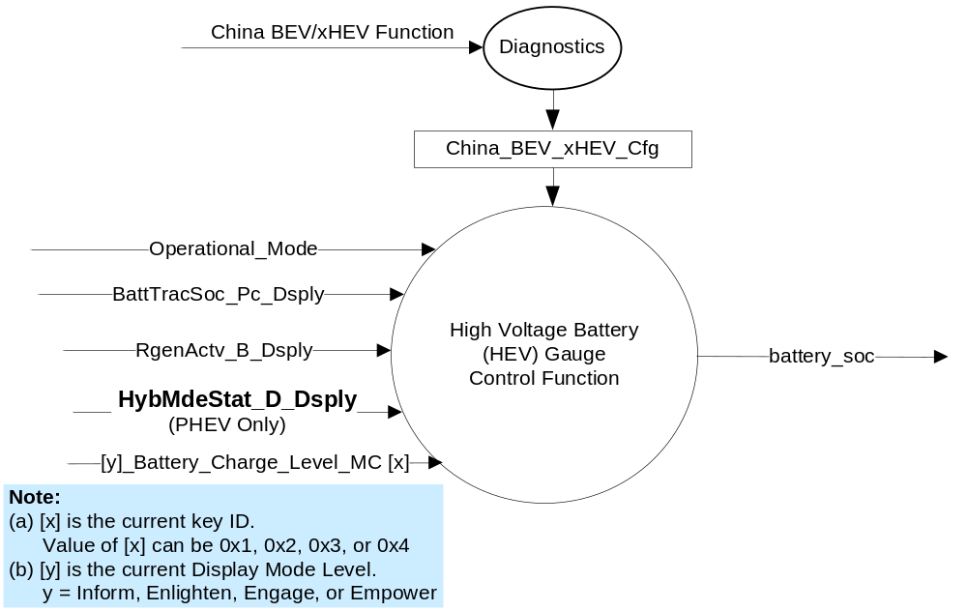

Inputs

- Internal:
- Operational Mode
- [y]_Battery_Charge_Level_MC [x], internal variable from Display Mode Subsystem (See note in Data Context Diagram). Possible values: Disabled (0x0), Enabled (0x1).

- MUX message on the CAN Bus
- BattTracSoc_Pc_Dsply Signal
Signal  Name | Size  (bits) | Detail | Units | Resolution | Offset | State  Encoded | Min. | Max.
BattTracSoc_Pc_Dsply | 8 |  | % | 0.5 | 0 |  | 0  (0x00) | 255  (0xFF)

- RegenActv_B_Dsply Signal

Signal  Name | Size  (bits) | Detail | Units | Resolution | Offset | State  Encoded | Min. | Max.
RgenActv_B_Dsply | 1 |  | SED | 1 | 0 |  | 0  (0x0) | 1  (0x1)
 |  | Off |  |  |  | 0x0
 |  | On |  |  |  | 0x1

- HybMdeStat_D_Dsply Signal

Signal  Name | Size  (bits) | Detail | Units | Resolution | Offset | State  Encoded | Min. | Max.
HybMdeStat_D_Dsply | 3 |  | SED | 1 | 0 |  | 0  (0x0) | 4  (0x4)
 |  | Null State |  |  |  | 0x0
 |  | Auto Charge Deplete Mode |  |  |  | 0x1
 |  | Auto Charge Sustain Mode |  |  |  | 0x2
 |  | Forced Charge Sustain Mode |  |  |  | 0x3
 |  | Forced EV Mode |  |  |  | 0x4
 |  | EV Override |  |  |  | 0x5
 |  | EV Charge |  |  |  | 0x6
 |  | NotUsed_1 |  |  |  | 0x7

Outputs
- battery_soc(%)
- charge_assist_indicator (possible values: None, charge in blue color, charge in gray/white color, assist)

Function/Performance

Operational Modes

Mode | Differentiating Vehicle Conditions
Sleep Mode | High Voltage Battery Gauge off
Limited Mode | High Voltage Battery Gauge off
Normal Mode | High Voltage Battery Gauge indicator at “High Voltage Battery Gauge”
Crank Mode | High Voltage Battery Gauge indicator at last “High Voltage Battery Gauge” determined in Normal Mode.

Voltage Levels

Human-Machine Interface

Visual

Indicator Graphics / Display Format
- High Voltage Battery Gauge Graphics

SNo | Mode | NA Graphics | China Graphics
1 | Sustain Batt w/o Regen | Not Applicable | Not Applicable
2 | Sustain Batt With Regen | Not Applicable | Not Applicable
3 | (+/-) Sustain With Regen |  | 
4 | Deplete Battery w/o Regen - PHEV |  | 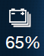
5 | Deplete Battery with Regen- PHEV |  | 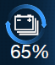
6 | Blank
7 | Locked Sustain Mode w/o Regen – PHEV |  | 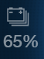
8 | Locked Sustain Mode with Regen – PHEV |  | 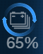

Refer to the Model(s) and specific graphics delivery for the exact Gauge Graphics

- Menu Settings - Regen Display

Variant | Menu Setting | Mode | Regen Event? |  | Battery Graphic
Variant | Regen Active Menu setting
PHEV | On | Sustain | No |  | 6. Blank
PHEV | On | Sustain | Yes |  | 3. +/- Sustain With Regen
PHEV | On | Deplete | No |  | 4. Deplete battery w/o Regen
PHEV | On | Deplete | Yes |  | 5. Deplete battery with Regen
PHEV | Off | Sustain | - |  | 6. Blank
PHEV | Off | Deplete | - |  | 4. Deplete battery w/o Regen
FHEV | On | Sustain | No |  | 6. Blank
FHEV | On | Sustain | Yes |  | 3. +/- Sustain With Regen
FHEV | On | Deplete | No |  | N/A
FHEV | On | Deplete | Yes |  | N/A
FHEV | Off | Sustain | - |  | 6. Blank
FHEV | Off | Deplete | - |  | N/A

- Deplete is always shown per gfx
- Regen active menu setting controls whether we show regen or not
- Battery fill SOC is always shown for dynamic fill content. For eg: 3 is static content and battery fill soc does not apply
- Regen Event is based on the RgenActv_B_Dsply CAN Signal

Example Menu for “Battery Display” and “Regen Display”:
Menu level 2 | Menu level 3 |  | Menu level 4
Display | Battery Display |  | T: Battery Display
 |  | ❍ | On
 |  | ● | Off
 | Regen Display |  | T: Regen Display
 |  | ● | On
 |  | ❍ | Off
Note: Battery Display Menu is no more applicable.
Defaults for these settings as shown in HMI menu above.

- Shall default “Regen Display” to On for both PHEV and FHEV and shall store user selection in battery backed RAM.

Indicator Color Coordinates

- Refer to the COLOR & ILLUMINATION REQUIREMENTS (GRAPHICS) Section (1.7) of the Master SPSS File

Indicator Characteristics
- “Scale Span” refers to the span delimited by the center lines of the “most positive” and “least positive” markings.
- “Operating Span” refers to the Gauge’s entire range of pointer movement over the graphics range.
- Refer to the "High Voltage Battery Gauge Transfer Function.xls" file for "Scale Span" and "Operating Span" in % scale of pointer indication.

Audio

None

Switch Control Logic

Not Applicable

System Accuracy

- Shall indicate the calculated output values as per the "HEV High Voltage Battery Gauge Transfer Function.xls" file, which is located in the same eRoom folder as this SPSS File

Operation: Performance and Functional

Subsystem Algorithm Flowchart / State Diagram

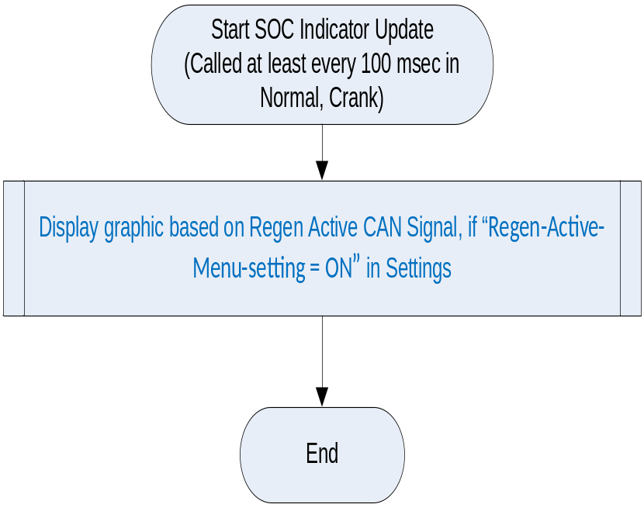

Battery_soc Control:

- HybMdeStat_D_Dsply Signal Mapping to Deplete/Sustain Mode

HybMdeStat_D_Dsply Signal | Charge Mode  (Deplete/Sustain)
= AutoChargeDepleteMode (0x1)  OR = ForcedEVMode (0x4)  OR = EVOverride (0x5)  OR = EV Charge (0x6)(Not Applicable to Gen 3)  OR = NotUsed2 (0x7)  OR = Null (0x0) | Deplete Mode
= AutoChargeSustainMode (0x2) | Sustain Mode
= ForcedChargeSustainMode (0x3) | Locked Sustain Mode

- battery_soc Control
Operational Mode | Charge Mode  (Deplete/Sustain) | BattTracSoc_Pc_Dsply | [y]_Battery_Charge_Level_MC[x]* | battery_soc
Normal | Sustain | <=200 | Enabled (0x1) | Fill with Filter  (BattTracSoc_Pc_Dsply)
Normal | Sustain | <=200 | Disabled (0x0) | No Fill  (Reset position)
Normal | Deplete or  Locked Sustain** | <=200 | x | Fill with Filter  (BattTracSoc_Pc_Dsply)
Normal | x | > 200 (data invalid) | x | No Fill  (Reset position)  (Implement as described in  missing/invalid message section)
Normal | x | Missing | x
Crank | x |  |  | Keep last level status  (determined in Normal Mode)
All Other Cases |  |  |  | No Fill  (Reset position)

* On PHEV and when Charge Mode = Deplete, SoC is always shown (Battery graphic is similar to BEV)

** Note that this is just a “grayed down” version of Depletion battery.

- Regen Active Graphic Indication

Operational  Mode | RgenActv_B_Dsply | Regen Active Graphic
Normal | Off | Display graphic 4 or 6 or 7 based on EV Mode
Normal | On | Display graphic 3 or 5 or 8 based on EV Mode
All Other Cases |  | Display blank (6) or based on EV Mode

- China/NA Graphics
SNo | EV Mode | China_BEV_xHEV_Cfg  DExx Configuration | Graphics
1 | Sustain Batt w/o Regen | Not Applicable | Not Applicable
2 | Sustain Batt With Regen | Not Applicable | Not Applicable
3 | (+/-) Sustain With Regen | Disable
3 | (+/-) Sustain With Regen | Enable
4 | Deplete Battery w/o Regen - PHEV | Disable
4 | Deplete Battery w/o Regen - PHEV | Enable
5 | Deplete Battery with Regen- PHEV | Disable
5 | Deplete Battery with Regen- PHEV | Enable
6 | Blank | Disable
6 | Blank | Enable
7 | Locked Sustain Mode w/o Regen – PHEV | Disable
7 | Locked Sustain Mode w/o Regen – PHEV | Enable
8 | Locked Sustain Mode with Regen – PHEV | Disable
8 | Locked Sustain Mode with Regen – PHEV | Enable

Operation Description (supports algorithm flowchart /state diagram)

- The Battery Gauge Rest Position” is graphically represented/defined as a NO FILL (blue) of the gauge.
- Gauge pointer/fill shall move to rest position at max rate when BattTracSoc_Pc_Dsply (CAN) Signal is missing or invalid consecutively for 5 seconds or more.
- The raw input from the BECM is filtered by the cluster for smooth and continuous pointer movement.
- The Battery Gauge shall not exhibit needle waver exceeding 0.3% of scale with a steady commanded input.
- Pointer/Fill overshoot and return to state of charge indicated by BattTracSoc_Pc_Dsply (CAN) Signal shall not exceed 1.0% of scale.
- The Battery Gauge shall sample the BattTracSoc_Pc_Dsply (CAN) Signal at the predefined message's periodic rate.
- The cluster shall use "battery_soc" to update the High Voltage Battery Gauge pointer position at least 100 msec.
- The Battery Gauge shall default to the “Rest Position” when in “Sleep Mode” or “Limited Mode”.
- Battery Gauge Filtering:
- The Gauge shall support a smooth filter rate that controls the filtering of rising and falling values displayed on the Gauge.
- The Gauge shall be initialized to the first valid signal value (0x00 -0xC8) received after:
- A transition to Normal/Crank from Sleep/Limited
- A recovery from the Rest Position for Missing Signals or Invalid values

Function Safety Classification (EMC)
B

Memory Storage

Parameter Name | Description | Value at  Battery Connect | Value at  Module Wake-up
battery_soc | Used to control the gauge pointer position. | 0 (at Rest Position) | 0 (at Rest Position)
Charge_assist_indicator | Used to control the display of up/down arrow. | “None” - 0 | “None” - 0
BattTracSoc_Pc_Dsply | CAN signal Battery state of charge (SOC) | As per CAN Message List | Do Not Init
DchrgActv_B_Dsply | CAN signal for Down arrow | As per CAN Message List | Do Not Init
ChrgActv_B_Dsply | CAN signal for Up arrow | As per CAN Message List | Do Not Init
RgenActv_B_Dsply  (CAN) Signal | CAN signal sent from PCM for Regenerative Braking status. | As per CAN Message List | Do Not Init
HybMdeStat_D_Dsply Signal | CAN signal input used on PHEV only to determine the charging mode and battery graphics to use. | As per CAN Message List | Do Not Init
[y]_Battery_Charge_Level_MC [x] | HEV display flag to indicate whether or not the “Battery Charge Level” option in the “y” view is enabled or disabled.  - [x] is the current key ID. Value of [x] can be 0x1, 0x2, 0x3, or 0x4.  - [y] is the current Display Mode Level. y = Inform, Enlighten, Engage, or Empower. | Use EE Stored Value | Use EE Stored Value
Operational_Mode | 4 state indicator for cluster operational mode | Limited | Limited, Normal or Crank

Prove Out
No

Error Handling

The State-of-Charge Gauge shall return to the “Rest Position” (No Fill) within 1000ms of determining an error condition as defined in 1.3.6.1 Subsystem Algorithm Flowchart / State Diagram.

Missing/Invalid Message Strategy
As determined per missing/Invalid Strategy for signal BattTracSoc_Pc_Dsply.

Diagnostics

Self Test
The gauge shall sweep the full range & return to the "Rest" position.

Engineering Test Mode
Reference section “Dealer / Engineering Test Mode (ETM)”

Part II Performance

Supported Diagnostic Trouble Codes (DTCs)

As per the Diagnostics Section of this SPSS.

DID DE09
Block  Num | Block Description | Byte(s) | Bits | State: Description | "0" | "1" | Default | Comments/Information
PACKETED BLOCKS
$09 | Option Content (B&A) | * | * | China BEV/xHEV Function | Not China | China | Not China | For China (Peoples Republic of China) must be set to China for compliance to China reg GB/T 4094.2-2005. Taiwan MUST be set to Not China.

Reference Specification

None

Revision History
SPSS Module Revision History

Revision Level | Name | Change Description | Date
1.0 | SWatkins | Initial release  - Charge_Mode temp. signal needs to be replaced with the actual CAN signal (future improvements for PHEV) | 5/17/11
1.1 | S. Watkins  M. Hakim | Replaced the temporary signal “Charge_Mode” with the correct signal “HybMdeStat_D_Dsply” all through the document. Added correct signal table, in section 1.2.2. Added signal mapping table, in section 1.3.5.1 | 12/06/11
2.0 | S. Watkins | Need to correct issue found on vehicle. The charge arrow should turn blue when the regen arrows are on. Thus, updating graphics and bringing in signal RgenActv_B_Dsply. (This signal is also used by Brake Coach Gauge Display – xEV STSS).  - Added signal RgenActv_B_Dsply to sections 1.1, 1.2.1, 1.2.2, 1.3.5.4  - Section 1.3.3.1.1 – Added comments about colors for charge active arrows.  - Section 1.3.5.1 – Re-wrote Table 8 (Charge Assist Indicator Control) to add in new signal RgenActv_B_Dsply and added in color description of charge arrows. | 3/20/2012
3.0 | S. Watkins | Added a new Charge Mode of Locked_Sustain. This has a new graphic, it takes the Depletion battery and grays it out slightly to show it is “saved” for later use (i.e. EV Later mode).  - 1.3.3.1.1 – Added comment to HEV for charge arrow color even if regen circles turned off.  - 1.3.3.1.1. – Added “c – Charge_Mode = Locked Sustain”  - 1.3.5.1 – Modified Table 6 and Table 7 for Locked Sustain. | 5/23/2012
4.0 | T. Cwik | Update to cover previously unspecified states for HybMdeStat_D_Dsply.  Section 1.3.5.1 – Added States 0x0, 0x6 and 0x7 to Table 6.  -- In Table 7, Moved “or Locked Sustain** “ from Sustain row to Deplete row | 7/26/2012
5.0 | R. Chalanti | Updated HMI Indicator Section 1.3.3.1 for battery graphics information  New graphics received for Battery SOC display and Regen Active Display. The “chevrons” for charge assist indication are no longer required as per EPE team decision.  Removed references of ChrgActv_B_Dsply and DchrgActv_B_Dsply signals and charge assist indicator  Added Menu Settings - Battery Graphics Display table  Modified Table 6 to show Regen Active Graphic indication | 6/16/2015
5.1 | S. Watkins | Direction for default display for “Battery Display” was not clear in STSS.  Thus, updating to show that default for “Battery Display” for both PHEV and FHEV in the menu is OFF.  Changes in teal:  - Page 4, added menu structure and defaults.  Original direction was set in DI CC on 9/12/2014: | 5/26/2017
  2) xEV SOC Battery Display
  MY17 xEV
  Feature Owners: |  | C.Esler
  Proposal to add State of charge gauge F/PHEV (Sustain mode battery)
  proposal to have feature default OFF but allow customer to turn it on via cluster setting
5.2 | H. Sharma | This changes are implemented based on inputs from EPE team : Charbel Bouery and Dale Gilman. Offline Approval: 02./19/2018. There are two major updates in this releases.  This update is only for China Market :  This change in China Market is required to meet the GBT4094.2 Regulation in China for any vehicle sold after July 2019 Date. Changes affect the HV Battery SOC display. Due to this regulation Battery Gauge SOC Display will be Changed with battery symbol and SOC%.  Global Update :  Battery Display Menu is no longer applicable and removed from Menu Structure.  All changes are marked in Bright Green Color. | 4/03/2018
5.3 | H. Sharma | This update is done to answer Denso Q&A:  Section 1.5.3 is updated to add China configuration. This update will add clarity to handle China and Non-China variations with same STSS. | 04/12/2018
5.4 | H. Sharma | This update is done to answer Denso Q&A:  Table 5 updated to correct Typo Error. | 05/31/2018

